**Abstract Classes and Methods in Java**

A class that is declared using “abstract” keyword is known as abstract class. It may or may not include abstract methods which means in abstract class you can have concrete methods (methods with body) as well along with abstract methods ( without an implementation, without braces, and followed by a semicolon). An abstract class can not be **instantiated** (you are not allowed to create **object** of Abstract class).

**Abstract class declaration**

Specifying **abstract keyword** before the class during declaration makes it abstract.

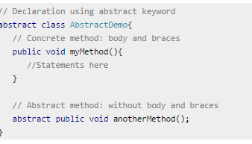

Since abstract class allows concrete methods as well, it does not provide 100% abstraction. You can say that it provides partial abstraction. Interfaces are used for 100% abstraction (full abstraction)

**Remember two rules:**  
1) If the class is having few abstract methods and few concrete methods: declare it as abstract class.  
2) If the class is having only abstract methods: declare it as interface.

**Error!! – Object creation of abstract class is not allowed**

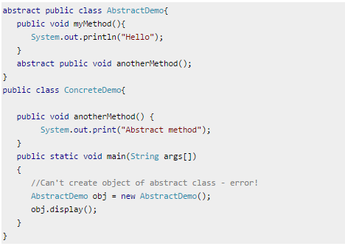

## Why we need an abstract class?

Suppose there is a class Animal and there are few other classes like Cat, Dog and Horse. These classes extends Animal class so basically they are having few common habits(methods in technically) which they are inheriting from Animal class. Now, if you have understood the above example then you would have been able to figure out that **creating object of Animal class has no significance** as you can’t judge that the **new** object of Animal class will represent which animal. Hence for such kind of scenarios we generally creates an **abstract class** and later **concrete classes** extends these classes and overrides their methods accordingly and can have their own methods as well.

**Key Points:**

1. An abstract class has no use until unless it is extended by some other class.
2. If you declare an abstract method (discussed below) in a class then you must declare the class abstract as well. you can’t have abstract method in a non-abstract class. It’s vice versa is not always true: If a class is not having any abstract method then also it can be marked as abstract.
3. Abstract class can have non-abstract method (concrete) as well.

## Abstract methods

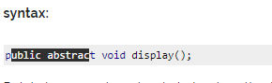

Points to remember about abstract method:  
1) Abstract method has no body.  
2) Always end the declaration with a **semicolon**(;).  
3) It must be **overridden**. An abstract class must be extended and in a same way abstract method must be overridden.  
4) Abstract method must be in a abstract class.

